Name: ________________________________ Date: ______________ Pd: ________
Unit 1: The World: How Geographers Look at the World
Globes and Map Projections
- Globe –

- Map –

  - Cartographers
Great Circle Route
The measured distance between any two points on a flat map will not have the same distance when measured on a round globe.
- Great circle route –

Map Projection

  - Distort
Must choose projection based on purpose of map
Planar Projection
- aka Azimuthal Projection

Often used for maps of the poles
Cylindrical Projection
- Mercator Projection

Most accurate at the Equator

Conic Projection

Winkel Tripel Projection

- Distorts:

- Provides :

Robinson Projection
East-West projections run in a straight line
- Distortions:

- Accuracy:

Winkel vs. Robinson

Goode’s Interrupted Equal-Area

- Accuracy:

- Distortion:

Explaining
- Why is a trip from Tokyo to Los Angeles a longer distance than it appears to be on a map?

Determining Location
- Grid System:

- Equator

- Prime Meridian
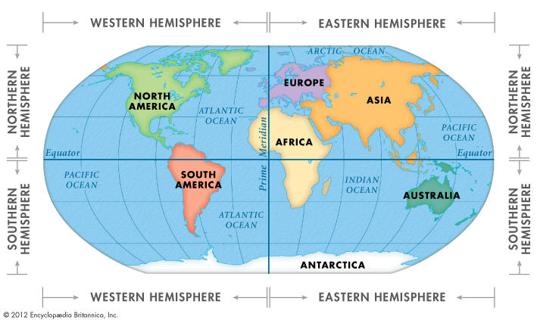
- Hemispheres
Important Lines of Lat. And Long.
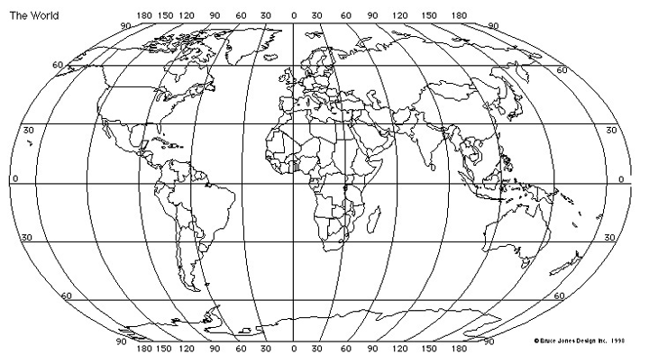
Determining Location
- Absolute location

Using Maps
- Components:

Scale

Physical Maps
- relief

Political Maps

Thematic Maps
Emphasize a particular theme or subject

Mental Maps

Geospatial Technologies
include global positioning systems (GPS), geographic information systems (GIS), and remote sensing from satellites and aircraft.
- GPS

- GIS

- Remote Sensing

Lesson 2
A Geographic Perspective
Geographers study the locations and relationships of Earth's physical and living features.
Spatial Perspective

- Used to examine:

- Local perspective –
- Global perspective –
- Ecological Perspective –

- Perspective of Experience –

- Conceptual Lens: Education
Based on your experiences in
school thus far, what is your
perspective on education?

Why is Geography Important to You?
- Teaching –

- Meteorologist –

- Emergency management officials (gov.) –

- Ecologists –

- Soil Scientists –

- Environmental managers –

Why is Geography Important to You?

- Human Geo:

5 Basic Skills Key to Geographic Understanding
- Asking
- Acquiring
- Organizing
- Analyzing
- Answering Geographic Questions

Progress Check
- List at least 3 fields outside
of geography that use
geography skills. Try not to
look at your notes.
6 Elements of Geography
- The World in Spatial Terms
- Places and Regions
- Physical Systems
- Human Systems
- Environment and Society
- Uses of Geography

1. The World in Spatial Terms
Spatial relationships link people and places based on their locations and relationships to each other
- Absolute location –
- Relative location –

  - Mental Maps –

- Site –
Ex: The site of O’Connor is located at the corner of Bandera and Leslie Road in Helotes
- Situation –
Ex: O’Connor is a high school in Helotes across the street from Wal-Mart and Taco Bell
2. Places and Regions
- Place –

- Region –
  - Physical Traits:

            - Human Significance:

Three Types of Regions
- Formal –

  - Ex:
- Functional –

  - Ex:
- Perceptual –

  - Ex: “Heartland” of the US – center of US where traditional values of family & hospitality predominate
3. Physical Systems
- Physical geo –

- Ecosystems

4. Human Systems
- Human geo –
- Human Migration & Settlement

5. Environment and Society
- Human-Environment Interaction

  - How people:
Change it voluntarily / involuntarily

  - How the environment:
- Natural Disasters

6. Uses of Geography
- Planning & policy making
- Urban planners

  - Goal:

- What types of jobs would urban planners hold?

Progress Check: Quickwrite
In your summary space: Describe each of the three types of regions in 3-5 sentences.

Research Methods
- Direct Observation & Measurement
  - Analysis of patterns of human activity that take place on Earth’s surface
  - Remote sensing –

- Mapping
  - Features:

    - Ex:

- Interviewing

  - Select a group to study

- Statistics

    - Ex:
    - Ex:

Geography & Other Subjects
Historical Perspectives

- Sources of historical data:

Political Patterns

- How do govs. change the natural environment?
  - Ex: Egypt – Aswan High Dam (Nile River

Sociology & Anthropology

Economics

- Factors:

Trade
Interdependence b/w global economies = relationships & communication b/w various cultures

Progress Check
What factors might a geographer study to learn about the economy of a particular country?
How is interdependence important to economic activity? How is geography related to other subjects?

